Reasoning the Flood of Noah

Since Joseph Smith and the Mormon Church have a strong basis in prophecy, it is essential to mention Smith’s revelation regarding the place where Adam dwelt.

[D&C 117:7-8](https://www.lds.org/scriptures/dc-testament/dc/117.7-8?lang=eng#p7)

Therefore, will I not make solitary places to bud and to blossom, and to bring forth in abundance? saith the Lord.

Is there not room enough on the mountains of Adam-ondi-Ahman, and on the plains of Olaha Shinehah, or the land where Adam dwelt, that you should covet that which is but the drop, and neglect the more weighty matters?

Adom-ondi-Ahman is located in northern Missouri west of the Grand River that empties into the Missouri river. It is currently fertile farmland, extensively owned by the Mormon Church. According to the Church, this is the place where Adam dwelt after leaving the Garden of Eden. You can continue along the Missouri River until it meets the Mississippi only about 100 miles north of the Ohio that also empties into the Mississippi. Anciently this could easily have accommodated four river heads as mentioned in Genesis, even if you do not count the lower Mississippi as one of the heads. This area fits Genesis far better than the Middle East. If this is where Adam dwelt, then Noah could have been close to the Mississippi where he built the Ark. It is perfectly logical that he might have experienced a flood far above normal. Even in modern times, the Mississippi would flood in some areas as far as the eye could see if it were not for dikes. The distant plains are often lower than the river due to surrounding deposits over many centuries. During a catastrophic flood, water would have appeared in every direction and taken the Ark into the Gulf of Mexico. Scientifically more plausible, Genesis, as well as the revelations of Joseph Smith will make one wonder.

A current aerial view of the area satisfies the geography of Genesis. It has plenty of rivers coming to a head, high mountains to represent the memory of Mount Ararat, and the geography surface is reminiscent of a catastrophic flood area. You cannot come close to this combined typography anywhere in the world with similar latitude. The area would also have to have access to the ocean and a reasonable distance to the Middle East. Above all, Noah's log would have to match the timing and observations along the way. We are not talking millions of years ago—only about 5000 years ago.

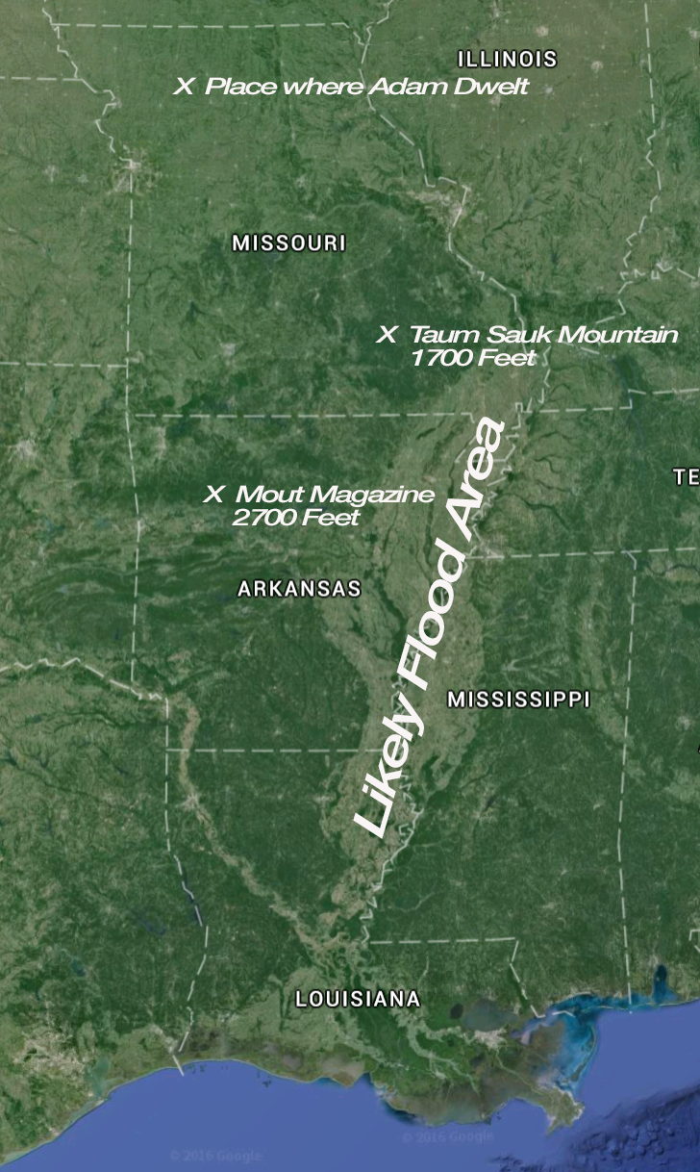

If the Lord had a purpose and He wanted to take Noah to the same destination as he will later take Abraham and again Moses, the Gaza Strip would be the closest to this plan. God's description of Noah's travels, given to Moses, provides specific months and days. The flood started Feb 17, 2344, BC. The source comes from the Great Pyramid. If one disbelieves this claim they can use their own date. It will make little difference to the conclusion that follows, being that the number of months and days following Geneses using thirty days per month.

February 17: “The waters of the flood upon the earth” 7:10, “in the second month, the seventeenth day of the month, the fountains of the great deep broken up, and the windows of heaven were opened” 7:11. “The ark went upon the face of the waters” 7:18. All the high hills, that were under the whole heaven, were covered” 7:19. “Fifteen cubits upward did the waters prevail; and the mountains were covered” 7:20. “God made a wind to pass over the earth, and the waters asswaged” 8:1.

March 27: "rain was upon the earth forty days and forty nights" 7:12; "and the flood was forty days upon the earth" 7:17; "the fountains also of the deep and the windows of heaven were stopped, and the rain from heaven was restrained" 8:2; "at the end of forty days, that Noah opened the window of the ark" 8:6. "He sent forth a raven, which went forth to and fro until the waters were dried up" 8:7, "Also he sent forth a dove from him…and she returned unto him into the ark: 8:8-9.

**Note:** There is no mention of a return of the raven only the return of the dove. Forty days would put the ark in the Gulf of Mexico or further out. A raven could have found an island south of the Florida coastline. It would make sense that land was not far off but not seen because the earth is curved.

April 4: "And he stayed yet other seven days, and again he sent forth the dove out of the ark…the dove came into him in the evening; and, lo, in her mouth was an olive leaf plucked off” 8:11.

April 11: "And he stayed yet another seven days, and sent forth the dove; which returned not again unto him."

**Note**: This is only fourteen days after the rains stopped and only 55 days from the start of the flood. The reader thinks this is at the end, but given the 150 days to Mount Ararat corrects this illusion. Only one-third of the time will have transpired to the reference of Mount Ararat. The same argument can be given that the ark is still off the coast of present-day America in the open Atlantic. The currents run up the coast and then across the Atlantic. Keep in mind that God provided this script to Moses. It is logical to assume it is the preserved record of Noah. The Lord would correct any falsehoods on the part of Noah unless they help cover the truth.

July 17: "And the waters prevailed upon the earth a hundred and fifty days" 7:24. "And the waters returned from off the earth continually: and after the end of the hundred and fifty days, the waters were abated" 7:3. "The ark rested in the seventh month, on the seventeenth day of the month, upon the mountains of Ararat" 8:4.

**Note**: 150 days is only half the total time from launch to landing given later from Feb 17 (600th year) to Jan 1st (601st year). This is almost a year. To say the ark rested on the mountains on July 17 is only 150 days later. The time between *when the waters were abated and the ark rested*, maybe more time, but it makes more sense that the Ark was approaching a landmass on the ocean, which was less active. If an island or distant land was spotted and the ark was moving relatively slowly, Noah could assume in his log that the land or island was the top of Mount Ararat—the mountain he saw diminished in height when the Mississippi was rising as the ark floated south. Perhaps Noah was not totally aware that the earth was curved and the mountains would recede as the river covered the land as far as the eye could see.

Noah may have seen more land in the first 30 days and 150 days later giving the open ocean in between. Perhaps Noah saw some distant Island such as modern-day Distrito de Ponta Delgada to the north or Funchal to the south of a path to the Straits of Gibraltar. These islands would be just a bit over half the distance in agreement with the total 320 days. It could even be the southern tip of our current Spain. If much land looking like islands was spotted at different times over a short period, Noah could still think that he was at a level near the tops of his former mountain Ararat.

*The ark rested in the seventh month, on the seventeenth day of the month.* This is about two and one-half months after spotting land. The next verse simply relates to seeing the mountains, which were only land at a distance.

October 1: After the waters decreased…were the tops of the mountains seen 8:5.

**Note**:After sighting an assumed Mount Ararat, there are still 140 days left before one can say the ark actually landed. Because the waters were “abated” could be the stillness of the water going through the Straits of Gibraltar. Perhaps this is where Noah saw the mountains, and the prior resting on Mount Ararat became an assumption of many years later. The sighting of mountains would be about two and one-half months of time. This could be from the first island until after they passed through the Straits. Then again, one would see no land. Noah does not mention this thinking he was perhaps drifting and waiting for the waters to recede more.

Jan 1: “And it came to pass in the six hundredth and first year, in the first month, the first day of the month the waters were dried up from off the earth: and Noah removed the covering of the ark, and looked, and, behold, the face of the ground was dry” 8:13.

Feb 27: “And in the second month, on the seven and twentieth day of the month, was the earth dried” 8:14.

**Note**: This is one full year and ten days living in the ark. They entered the ark in Noah's 600th year and left it in his 601st year (Compare Genesis 7:11 with 8:13). The Lord made Noah wait in the Ark from Jan. 1 to Feb 27. This gives the impression the land was not dry enough or they saw land but not close. The movement would be even slower at this point. The ark did not settle until after a low tide. The position of the sun and moon may have more to do with this timing. Even a change in seasons might be the reason. The Gaza Strip would provide an ideal environment for the landing of the ark and fit the timeline.

Noah repeated the story in two chapters. Both chapter 7 and 8 have different aspects of the entire trip. The reader is lead to a consecutive order and misses the repetition with different expressions. The dating provides the correct timeline, as will prophecy.

**Hebrew Note**: If you use a Hebrew calendar, the year would begin in September and end in September on a particular date depending upon whether it was a leap year. The flood would have begun in our fall depending on one's knowledge and calculations. The ark would have landed about one year later. The months given above are not Hebrew but the calculations are comparable with modern origins.

Teams of evangelical Christian explorers claim they have found the remains of Noah's ark beneath snow and volcanic debris on Turkey's Mount Ararat. Archaeologists and historians take this claim about as seriously as they have past attempts in Iran and under water. "I don't know of any expedition that ever went looking for the ark and didn't find it," said Paul Zimansky, an archaeologist specializing in the Middle East at Stony Brook University in New York State. Religious fanatics do not use the principles of reason and probability. They take things literally without the use of any relational thinking as attempted here when describing of the flood.

**Biological Clocks**

Perhaps the Lord wanted to reserve the former land for later times. Perhaps the change of location on the planet would reduce the average age of those living.

Noah was 600 years old when he left and died a little over 200 years later. Shem was approximately 100 years when he left and died when about 600 years old. All generations after Shem, except Eber, died before Shem. Even Abraham died before Shem passed away.

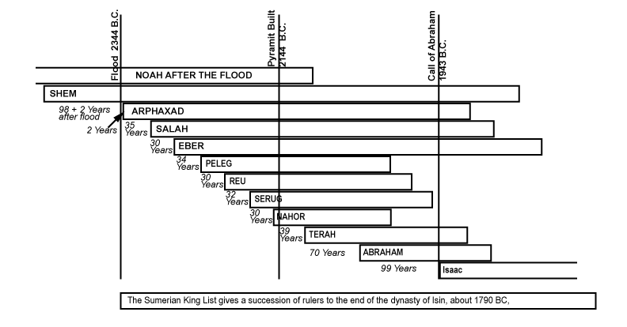

In order to understand the long lives of the first patriarchs, a physical theory needs to be covered. Just as there arises a more logical basis for the flood, the following will help to identify a more probable reason why Adam and Noah lived so long. What follows cannot explain in any entirety, for God can set their biological clocks as he wishes. In addition, the argument is not essential for the longevity of life, but it will be more in agreement to Carbon 14 Dating. Surely, this issue will come up in the Theory of Evolution if one wants to consider it.

Not intended to disavow Carbon 14 Dating, but rather to adjust it into a more accurate form, this theory presents a more logical process rather than strictly assuming the constant velocity of light, Carbon 14 dating always puts the date of events further back in time than many normal archeological sequences gleaned from records. The dates of civilizations, adjusted from previous scientific conclusions derived from Carbon 14 dating, fall back to something more rational and give possible reasons for long life spans for Adam and Noah. Recent civilizations within thousands of years do seem to be closer in agreement to Carbon 14 Dating and this seems to seal its authenticity.

The following is derived from *The* *Einstein Illusion* by this author and covers as brief as possible the basic elements.

**E=mc2**

An equation with a misunderstood concept regarding popular relativity proposes to prove conversion from energy to mass and back to energy. This has been demonstrated observationally using assumed concepts about light, but it does not follow logical protocol. The letter *m* in the equation refers to *mass* and the *E* relates to *energy*. If a mass is zero, then energy becomes zero. You cannot measure any form of energy without mass. It is not a conversion. It is a change in the type of energy or a type of motion of the mass. When a particle explodes, it appears as something solid and then breaks into pieces as each photon accelerates to the velocity of light. Relativity thinks of a piece of solid turning into pure energy as if something can have energy without mass. Relativity defines light as having no mass, yet the equation does not say this. One might call it Maxwellian enchanted energy because Maxwell did not believe energy fields had substance, yet a Mormon would conclude, “All spirit is mater.”

Einstein proved that high-energy photons have a greater push than low energy photons, yet modern relativity assumes that every photon has the same velocity and zero mass. Logically either the velocity or the mass has to be different or a combination of both, otherwise, the meaning of light is not logical to the equation. Faraday postulated smaller pieces of any matter before Einstein's use of photon. Einstein, however, used Maxwell's equations and his meaning. The equations were not the problem because they matched Faraday's experiments. Maxwell's denial of magnetic and electric particles sealed the fate of Modern Relativity. If magnetic and electric monopoles existed, relativity would define events in normal algebraic terms. The problem stems from the meaning of the terms such as light and mass and not the equations.

Picture the angular momentum of an electric field in a stationary position. According to the equations, there would also be the right-angle magnetic field that would keep the electric field in this stationary position. Then imagine being able to reach in with your hand and stop the magnetic field from circulating. What would happen to the electric field? The angular momentum has to go somewhere. Since nothing has stopped the electric field, it still must react with the same frequency of momentum as before the magnetic field was halted. Solution: the electric field spirals off the magnetic axis and travels the immensity of space until it meets an identical angular moving magnetic field to the one left behind. What then determines the linear velocity of the electric spiral? Simply put the space between the emission source and the absorbed electric particle to the new magnetic environment. What is between the two places? Would it not be magnetic properties at rest or so slow that the right angle motion is negligible. This is logically determined by measuring the motion of the earth’s magnetic field on the earth’s surface compared to its motion far out in space. It would be almost at rest at some far distance away from the earth or any massive body.

If such an analog fits reality without changing any equation, the modern physicist has to admit two principles. First, light does not travel at a constant velocity. Second, space and time return to their normal conditions. It is the assumed constant velocity of light that causes the usual though experiments in relativity. If one considers every experiment done to prove relativity by observation with these two conditions in mind, the variable velocity will smooth out every paradox of relativity without changing a single equation. If light moves more slowly in a dense magnetic field such as on the surface of a prism, it also curves because one side or the electric spiral touches a greater magnetic density before the other edge within less magnetic density. This model also explains the curvature of gravity. We have unified all forces in nature with a variable velocity of light to the variable magnetic flux density of space.

**Atomic Clocks**

Based on their ability to measure the movement of light transferred from one atom to another, atomic clocks assume that the velocity of light is constant within the atoms and therefore accurate enough in the use as a timepiece. The oscillation becomes a sophisticated measuring device when wired to an electronic digital read-out. Carbon 14 dating bases its clock on a similar principle. We know that if we place one of these clocks at a high elevation it runs faster than at sea level. Linear thinking assumes gravity as the cause. Relational thinking asks if the magnetic density is the cause? If the magnetic density diminishes proportional to the elevation, then all things will curve. All Matter will curve twice that of light because it has double the baggage of electric fields (half moving vertically to the other half moving horizontally) as it moves through a variable magnetic density. This agrees with Einstein's General Relativity Principle. It also eliminates the paradoxical illusions in his Special Relativity Principle—simply by allowing a variable velocity of light relational to variable magnetic density.

The only experiment performed with atomic clocks is to show that these clocks moving on a jet airliner in the westerly direction move faster than clocks traveling in the easterly direction. The argument given is the velocity and altitude of the jet, but that does not explain the differences in direction. Relational thinking asks for the state of the magnetic field relative to the two directions. The earth curves in the magnetic field and the westerly direction would put the airliner more at rest relative to the north-south magnetic lines. In the easterly direction, the airline would be passing through more north-south magnetic lines and thus a greater apparent density of magnetic particles—as Faraday postulated. The clock would read a slower time. While apparent time is still absolute, the atomic clock moves more slowly and not time. Atomic clocks are not as accurate as the moon and sun cycles.

The first experiment done to prove that the aether did not exist agrees with magnetic density. Instead of an assumed solid aether, a specific place on the earth had a constant east-west magnetic density causing the light from a distant star entering the vacuum to have a constant velocity regardless of the motion of the earth or the direction of a distant star. The magnetic density remains constant in any particular place thus the light appears constant, thus *c2* became the constant velocity of light in error. It should have been the variable velocity of light squared. There is no change in the equation. Only with the meaning of the terms that caused relativity to enter a state of magic. A simple experiment by placing one atomic clock at the magnetic north and another at the equator will determine the validity of this argument. The one at the magnetic north where the lines converge will be denser than the one at the equator. Also, have two clocks on their own Jet, one in the southern hemisphere near the magnetic south and the other near the magnetic north. Have both jets move at the same velocity to the opposite location and you will be able to determine the direction of the magnetic field. This will also show whether the magnetic relation obeys the right-hand rule or the left-hand rule relative to the motion of the earth.

Biological Engineering then depends upon the location of the organism relative to a specific magnetic density—the greater the density the longer the lifespan. This may have less to do with the length of life and more to the first weeks of embryonic growth affecting the overall lifespan or even the genetics. This would agree with Astrology, which really considers the planets and the sun having magnetic fields that affect the earth depending on the time of day and the location of the planets at birth or conception. If this affects the new life at the critical stages, the precise magnetic density could be the cause. It is the magnetic density in the area of new life, which determines many different outcomes, age being only one.

The earth’s magnetic field has flipped many times. The actual time between reversals varies. Since 1840, when accurate measures of the magnetic field intensity first appeared, the field strength has declined by about 5 percent per century. If this decline is continuous, the magnetic field could drop to zero and reverse sometime within the next 2,000 years. The field might not always be in steady decline. The data shows that field strength was relatively stable at times and happens in steps. In addition, the magnetic north location differed about 3000 BC. It was much further south toward the Great Lakes—just above the place where Adam dwelt. The higher magnetic density also protects the Earth from cosmic radiation. In the absence or diminished state of the magnetic field, humans and other animals would receive exposure to additional health hazards. The intensity of the magnetic field then can also contribute to our lifespan. If the magnetic intensity was greater before 3000 BC, less radiation could have affected early development and thus the lifespan.

As with atomic clocks, carbon 14 emissions would be faster at a higher elevation and slower at sea level. If such is the case, we cannot assume that these emissions would have the same rate of emission far back in time as they do today. Would the magnetic density change over time? Would conditions have been different before Noah? This is speculation, but if magnetic conditions differ over time, this is a good question when considering how the paradoxes of relativity can be resolved and the further back if magnetic conditions differed. If the magnetic density of the surface of the earth was greater the further back in time, Carbon 14 dating would assume an older fossil.

The biblical description and perhaps the results of Carbon 14 dating arise to a more meaningful understanding when the magnetic field density affects things. The half-life would differ depending on the magnetic density over time. The same misunderstanding that led modern physics down the path of relativity confusion could also have led evolution down an equally strange path.

We now have some reasoning of the ages of old and the path of the Ark. It is possible next to determine the Land of Shinar.